The Islamia University of Bahawalpur
Faculty of computing
Department of Information Technology

Project Software Requirement Specification
For

AI-Powered Multi-Courier Dropshipping System
Submitted By
Muhammad Shahzad
S23BINFT1M01133

Session SPRING 2023 – 2027

Supervisor
Prof. Dr Mustafa Hameed

1. Introduction

1.1 Purpose
The purpose of this document is to provide a detailed overview of the software requirements for the AI-Powered Multi-Courier Dropshipping System. This document describes the project's target audience, user interface, hardware and software requirements, and key features.

1.2 Scope
This system is a local dropshipping marketplace designed specifically for the Pakistani market. The primary goal is to allow verified sellers to purchase products from our platform, choose their preferred courier (TCS, MNP, Leopard, etc.), and resell them. The system will manage product listings, courier selection, and secure wallet-based payments.

1.3 Definitions and Acronyms

Term | Definition
SRS | Software Requirements Specification
COD | Cash on Delivery
2FA | Two-Factor Authentication
API | Application Programming Interface
TCS | Trakker Courier Services
MNP | MNP Courier
Admin | Platform Administrator

1.4 References
- TCS API Documentation
- Leopard Courier API Documentation
- JazzCash Payment Gateway Documentation
- Easypaisa API Documentation
- Facebook Business Manager API Documentation
- TikTok Ads API Documentation

2. Overall Description

2.1 Product Perspective
This system is a standalone web-based application that integrates with external courier services, payment gateways, and social media advertising platforms.

2.2 System Architecture Diagram

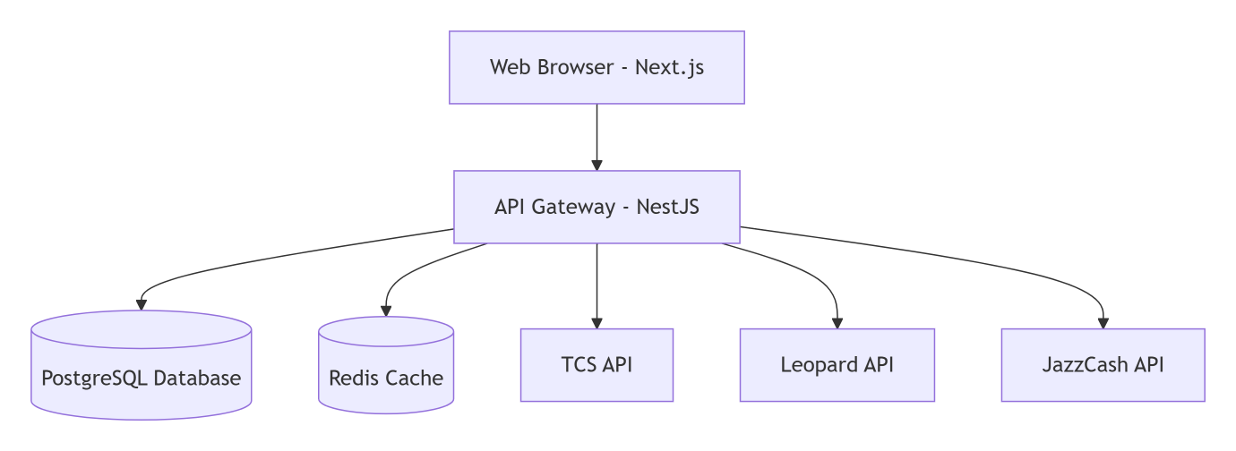

2.3 User Roles and Permissions

Feature | Seller | Admin
Browse Products | ✅ | ✅
Place Orders | ✅ | ✅
Manage Wallet | ✅ | ✅
Track Orders | ✅ | ✅
View Analytics | ✅ | ✅
Boost Ads | ✅ | ❌
Negotiate Prices | ✅ | ✅
Manage Products | ❌ | ✅
Verify Sellers | ❌ | ✅
Manage Courier Integrations | ❌ | ✅

2.4 Assumptions and Dependencies
Assumptions:
- Sellers have stable internet connectivity
- Sellers have a valid CNIC for verification
- Courier services provide reliable APIs

Dependencies:
- Courier API availability and uptime
- Payment gateway regulatory compliance
- Social media API rate limits and policies

2.5 Order Flow Diagram

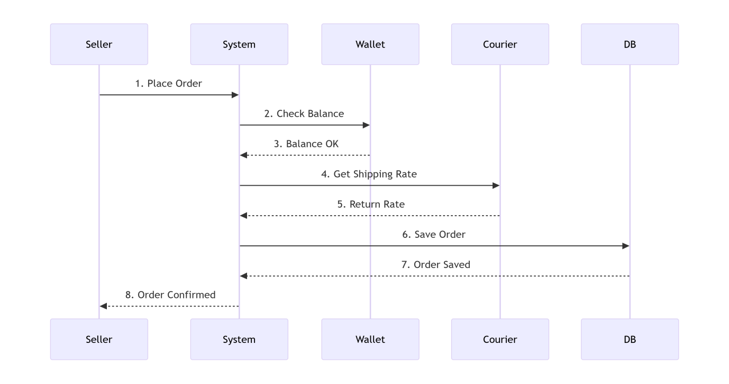

3. Functional Requirements

3.1 Seller Authentication & Verification

ID | Requirement | Priority
FR-01 | System shall allow new users to register with email, phone number, and CNIC | High
FR-02 | System shall send OTP verification to registered mobile number | High
FR-03 | Admin shall manually verify seller documents before activation | High
FR-04 | System shall support login with email/phone and password | High
FR-05 | System shall support password reset via email/SMS | High
FR-06 | System shall support two-factor authentication (2FA) for withdrawals | Medium

3.2 Product Management

ID | Requirement | Priority
FR-07 | Admin shall be able to add new products with title, description, images, price, stock, and category | High
FR-08 | Admin shall be able to edit or delete existing products | High
FR-09 | System shall automatically reduce stock when an order is placed | High
FR-10 | System shall send low-stock alerts to admin when stock < 10 units | Medium
FR-11 | Sellers shall be able to browse products with search and filter functionality | High
FR-12 | Sellers shall be able to view product details including images, price, and rating | High

3.3 Order Management

ID | Requirement | Priority
FR-13 | Sellers shall be able to add products to cart and proceed to checkout | High
FR-14 | System shall calculate order total including product price and shipping cost | High
FR-15 | Sellers shall be able to pay via wallet balance or COD | High
FR-16 | System shall generate a unique order ID for each order | High
FR-17 | Sellers shall be able to view order history with status | High
FR-18 | Admin shall be able to view and manage all orders | High

3.4 Multi-Courier Integration

ID | Requirement | Priority
FR-19 | System shall integrate with TCS, Leopard, and MNP courier services | High
FR-20 | System shall fetch real-time shipping rates based on destination and weight | High
FR-21 | Sellers shall be able to select any available courier at checkout | High
FR-22 | System shall generate shipping labels automatically after order confirmation | High
FR-23 | System shall store courier tracking IDs for each order | High

3.5 Wallet System

ID | Requirement | Priority
FR-24 | Each seller shall have a digital wallet with a unique wallet ID | High
FR-25 | Sellers shall be able to deposit funds via JazzCash and Easypaisa | High
FR-26 | Sellers shall be able to withdraw funds to bank account or mobile wallet | High
FR-27 | System shall deduct order amount from wallet automatically upon order placement | High
FR-28 | System shall maintain an immutable transaction ledger for audit purposes | High
FR-29 | Sellers shall be able to view full transaction history | High
FR-30 | System shall require 2FA for any withdrawal request | High

3.6 AI-Powered Courier Optimization

ID | Requirement | Priority
FR-31 | System shall collect and store historical courier performance data (delivery time, success rate) | High
FR-32 | System shall allow sellers to set preference: "Lowest Cost" or "Fastest Delivery" | High
FR-33 | System shall recommend the best courier based on seller preference and historical data | High
FR-34 | System shall display AI recommendation with reasoning (e.g., "Leopard: Cheaper by Rs. 50") | Medium
FR-35 | System shall retrain AI model weekly with new delivery data | Low

3.7 Real-Time Order Tracking

ID | Requirement | Priority
FR-36 | System shall display real-time order status (Pending, Processing, Shipped, Delivered, Cancelled) | High
FR-37 | System shall show live tracking information from selected courier | High
FR-38 | System shall send push notifications when order status changes | High
FR-39 | Sellers shall be able to view estimated delivery date | Medium
FR-40 | System shall provide a map view for tracking (if courier API supports) | Low

3.8 Review & Rating System

ID | Requirement | Priority
FR-41 | Sellers shall be able to rate products after delivery (1 to 5 stars) | High
FR-42 | Sellers shall be able to write text reviews for products | High
FR-43 | System shall display average rating for each product | High
FR-44 | Admin shall be able to rate sellers based on payment behavior and dispute history | Medium
FR-45 | Seller ratings shall be visible to all sellers | Medium

3.9 Data Dashboard & Analytics

ID | Requirement | Priority
FR-46 | Sellers shall see a dashboard with key metrics: total orders, total spent, average order value | High
FR-47 | System shall display sales trends with charts (daily, weekly, monthly) | High
FR-48 | System shall show best-selling products and profit margins | High
FR-49 | System shall show courier performance comparison (delivery time by courier) | Medium
FR-50 | System shall allow exporting reports as CSV or PDF | Low

3.10 Ad Boosting System

ID | Requirement | Priority
FR-51 | Sellers shall be able to promote any product via Facebook and TikTok ads | High
FR-52 | Seller shall set daily budget, duration, and target audience (age, location, interests) | High
FR-53 | System shall automatically create ad creative using product images | Medium
FR-54 | System shall display ad performance metrics (impressions, clicks, spend) | High
FR-55 | Seller shall be able to pause, resume, or stop ad campaigns | Medium

3.11 Real-Time Negotiation

ID | Requirement | Priority
FR-56 | Sellers shall be able to initiate a negotiation with admin on product prices | High
FR-57 | System shall provide real-time chat interface using WebSockets | High
FR-58 | Seller or admin shall be able to send, accept, reject, or counter offers | High
FR-59 | System shall notify both parties of new messages and offers | High
FR-60 | System shall save chat history for audit purposes | Medium

3.12 Automated Notifications

ID | Requirement | Priority
FR-61 | System shall send email confirmation for order placement | High
FR-62 | System shall send SMS for shipping label generation | High
FR-63 | System shall send push notifications for delivery updates | High
FR-64 | System shall send low-stock alerts to admin | Medium
FR-65 | System shall send weekly order summary digest to sellers | Low

4. Non-Functional Requirements

4.1 Performance Requirements

ID | Requirement | Target
NFR-01 | Page load time (first contentful paint) | < 2 seconds
NFR-02 | API response time (95th percentile) | < 500 ms
NFR-03 | Concurrent user support | 500+ users
NFR-04 | Order processing time | < 3 seconds
NFR-05 | AI recommendation response time | < 1 second

4.2 Security Requirements

ID | Requirement
NFR-06 | All user passwords must be hashed using bcrypt
NFR-07 | All API communications must use HTTPS/TLS 1.2+
NFR-08 | Wallet transactions must be logged in an immutable audit trail
NFR-09 | Session timeout after 30 minutes of inactivity
NFR-10 | Two-factor authentication required for all withdrawals
NFR-11 | Regular security audits must be conducted quarterly

4.3 Availability Requirements

ID | Requirement | Target
NFR-12 | System uptime | 99.9% (excluding planned maintenance)
NFR-13 | Backup frequency | Daily automated backups
NFR-14 | Disaster recovery time (RTO) | < 4 hours

4.4 Scalability Requirements

ID | Requirement
NFR-15 | System shall support horizontal scaling (adding more servers)
NFR-16 | Database shall support sharding for large datasets
NFR-17 | Caching (Redis) shall be implemented for frequently accessed data

4.5 Usability Requirements

ID | Requirement
NFR-18 | System shall be responsive and work on mobile devices
NFR-19 | UI shall support both English and Urdu languages
NFR-20 | Navigation shall require no more than 3 clicks to reach any feature

4.6 Database ER Diagram

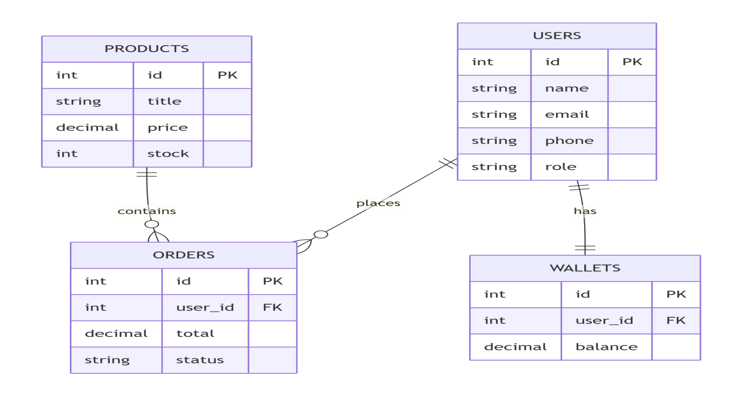

5. External Interface Requirements

5.1 Courier APIs

Courier | Endpoint Type | Data Exchanged
TCS | REST API | Rate calculation, label generation, tracking
Leopard | REST API | Rate calculation, tracking
MNP | REST API | Rate calculation, label generation, tracking

5.2 Payment Gateways

Gateway | Integration Type | Purpose
JazzCash | REST API | Wallet deposits and withdrawals
Easypaisa | REST API | Wallet deposits and withdrawals

5.3 Social Media APIs

Platform | API | Purpose
Facebook | Business Manager API | Ad creation and management
TikTok | Ads API | Ad creation and management

5.4 User Interface Requirements
- Web-based responsive design
- Mobile-friendly layout (Bootstrap or Tailwind CSS)
- Dashboard with charts (Chart.js or Recharts)
- Real-time chat interface

5.5 Shipping Label Generation

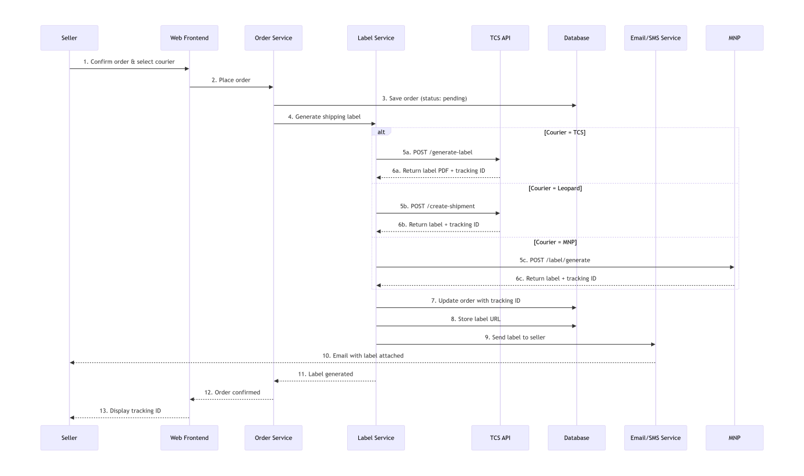

6. Database Requirements

6.1 Main Entities

Entity | Description
Users | Seller and admin accounts
Products | Product catalog managed by admin
Categories | Product categories
Orders | Order details and status
Order Items | Individual products within an order
Wallets | Seller wallet balances
Transactions | All wallet deposit, withdrawal, and payment records
Courier Shipments | Shipping labels and tracking information
Reviews | Product ratings and reviews
Notifications | User notification records
Negotiations | Chat and offer history
Ad Campaigns | Social media ad campaign data

7. Security Requirements

ID | Requirement
SR-01 | All financial transactions must be ACID compliant
SR-02 | Wallet balance must be stored in encrypted format
SR-03 | Audit logs must be kept for 7 years for financial transactions
SR-04 | Role-based access control (RBAC) for all endpoints
SR-05 | Rate limiting to prevent brute force attacks
SR-06 | Input validation and sanitization to prevent SQL injection and XSS

8. Constraints and Assumptions

8.1 Technical Constraints
- System must be web-based (no mobile app in Phase 1)
- Courier API rate limits may affect real-time tracking frequency
- Social media ad campaigns subject to platform approval and policies

8.2 Business Constraints
- Only verified sellers can place orders
- Minimum wallet balance of PKR 500 for withdrawals
- COD orders require seller verification level 2

8.3 Assumptions
- Sellers have basic understanding of e-commerce
- Courier APIs are available 99% of the time
- Sellers have valid bank accounts or mobile wallets for withdrawals

9. Prioritized Feature List

Priority | Feature
P0 (Must Have) | Seller authentication, product catalog, order placement, wallet system, basic courier integration
P1 (Should Have) | AI courier optimization, real-time tracking, notifications, review system
P2 (Nice to Have) | Ad boosting, real-time negotiation, advanced analytics

10. System Overview Diagram

